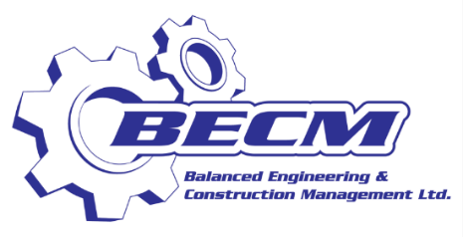

GRADUATE TRAINEE PROGRAMME 2023

BECM Ltd is inviting applications for our Graduate Trainee Program for the year 2023 for University Graduates to be given an opportunity to enhance their knowledge, stretch their capabilities and receive industry experience.

The programme will run for One Year commencing July 2023. The successful applicants will be assigned to our Engineering and Corporate Shared Services Departments.

Eligibility Requirements
- Minimum GPA of 3.0
- Have no more than two (2) year’s work experience
- Mechanical Engineering Department: you must have completed Bachelor’s degree in Mechanical Engineering between 2021- 2023
- Shared Services Department: you must have completed Bachelor’s degree in any of the following between 2021-2023:
- Management
- Finance
- Human Resources
- Information Technology

Interested applicants should send their resumes, transcripts and relevant certificates to renee.duval@becml.com. Please include BECM Ltd. Graduate Trainee Programme 2023 in the subject of the email.

The closing date for receipt of Applications is 16th June 2023.

All applications will be reviewed, and selections finalized based on the best fit.

